**CRM Application For Jewel Management - (Developer)**

College Name: Tirupur Kumaran College for women

College Code: bru3j

Team ID: NM2025TMID28368

Team Members: 4

Team Leader Name: JAYASREE R

Email: [jayasreer355@gmail.com](mailto:jayasreer355@gmail.com)

Team Member1: MYTHILI PRIYA

Email: mythilipriya026@gmail.com

Team Member2: JAYAPRIYA S

Email: rajeshaj900@gmail.com

Team Member3: ABINAYA SRI

Email: abinayasri9366@ gmail.com

**1.INTRODUCTION**

* 1. **Project Overview**
* The Jewel Inventory System is a comprehensive software Solution designed to streamline and manage the inventory and sales processes of a jewellery store or a jewellery manufacturer.
* The system aims to provide an efficient and user-friendly solution to track and control the inventory of various jewellery items, maintain accurate records, and facilitate seamless sales transactions

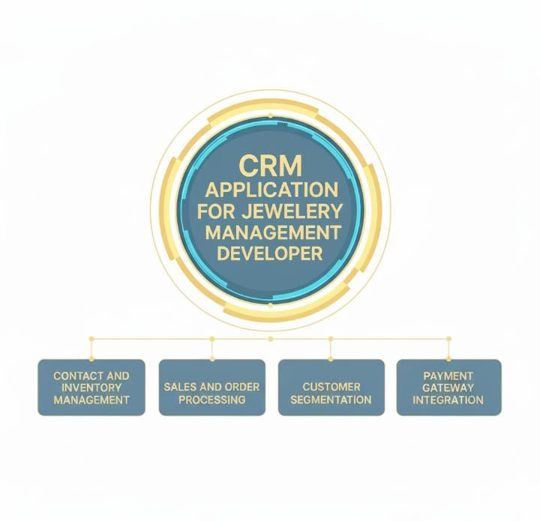

**1.2 Purpose**

The Main objective of the project is centralizes customer data,automates,marketing,and personalizes customer interactions to build loyalty and drive sales growth,track sales it optimize the entire customer jorney from lead to post-sale support.

**DEVELOPMENT PHASE**

**Creating Developer Account:** By using this URL-<https://developer.salesforce.com/signup>

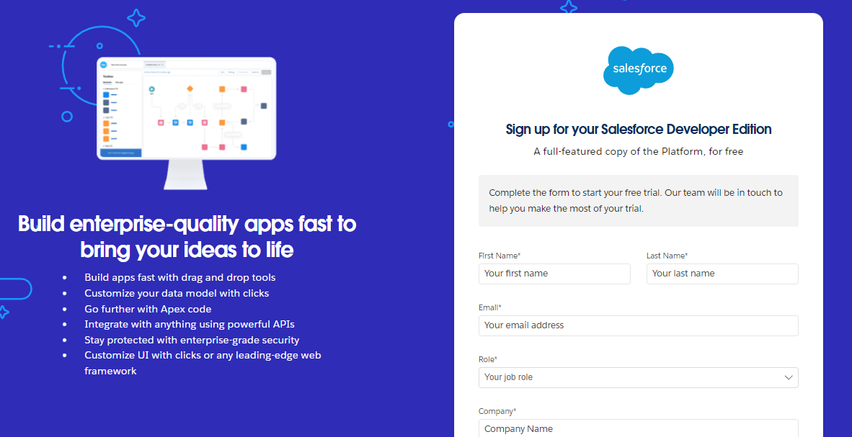

Next to activate a Account activation for Salesforce project by using userid and id.

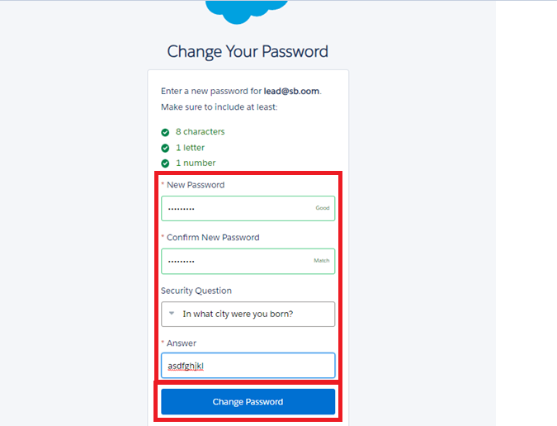

Then, Redirect into Salesforce setup page.

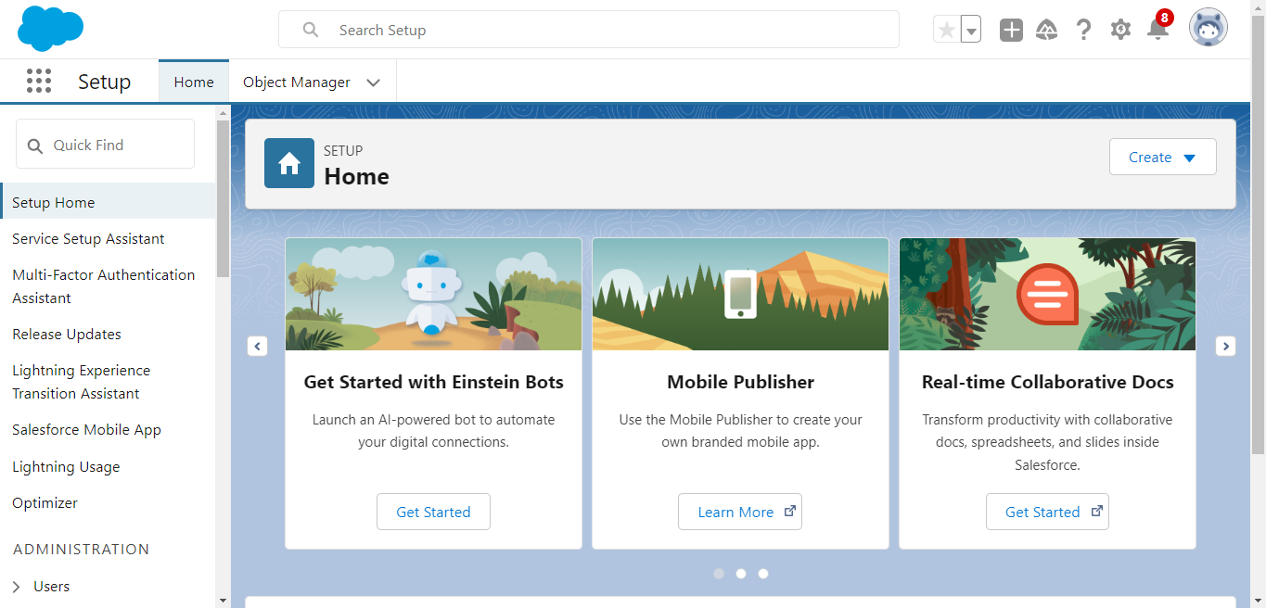

**Create Jewel Customer Object**

The purpose of creating a Jewel Customer custom object is to store and manage information about Customer.

To create an object:

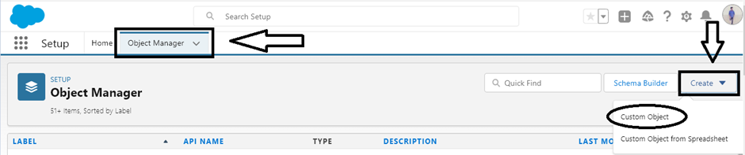

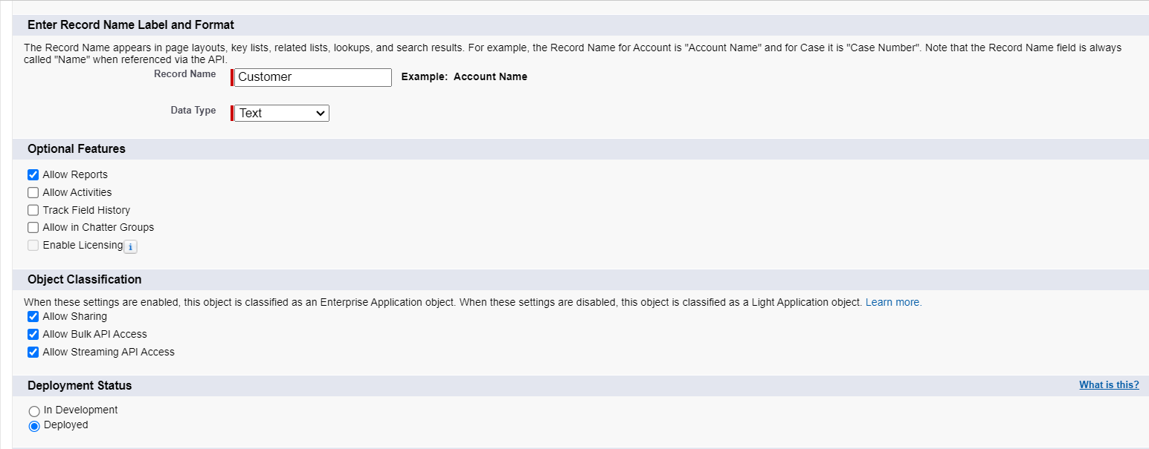

**Create Item oject, Customer order, Price,Billing.**

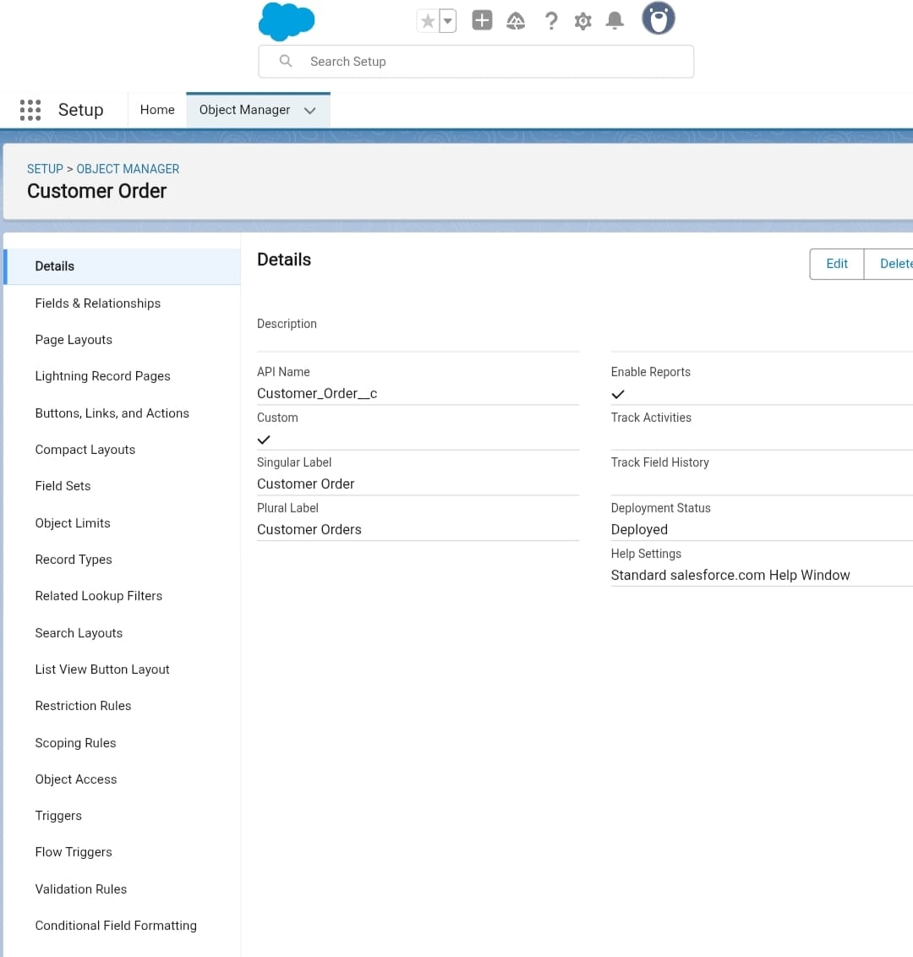

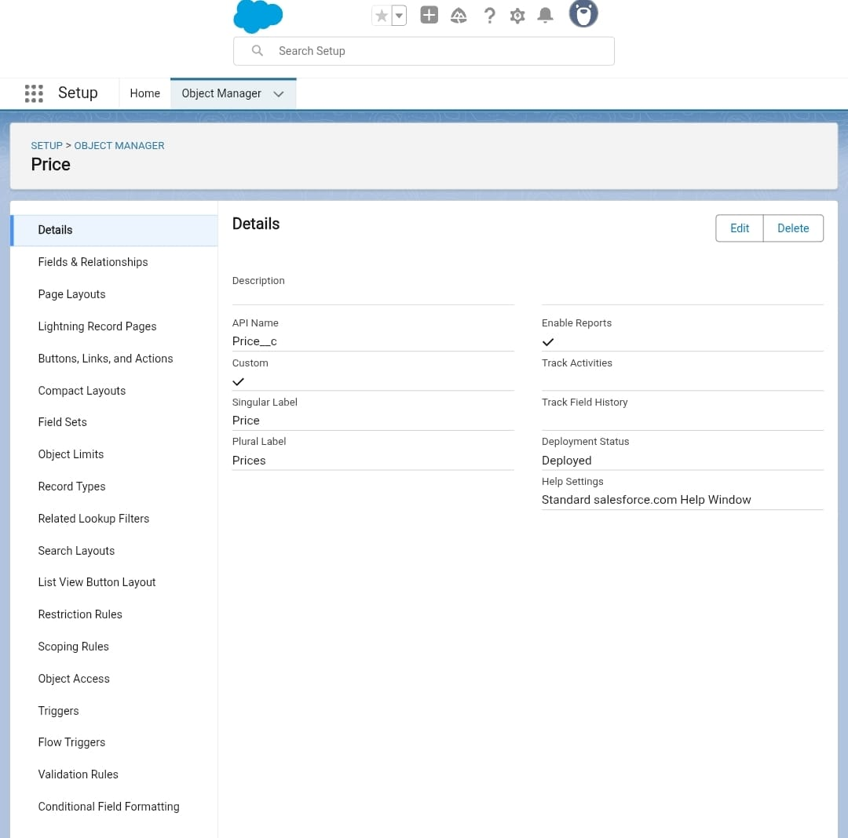

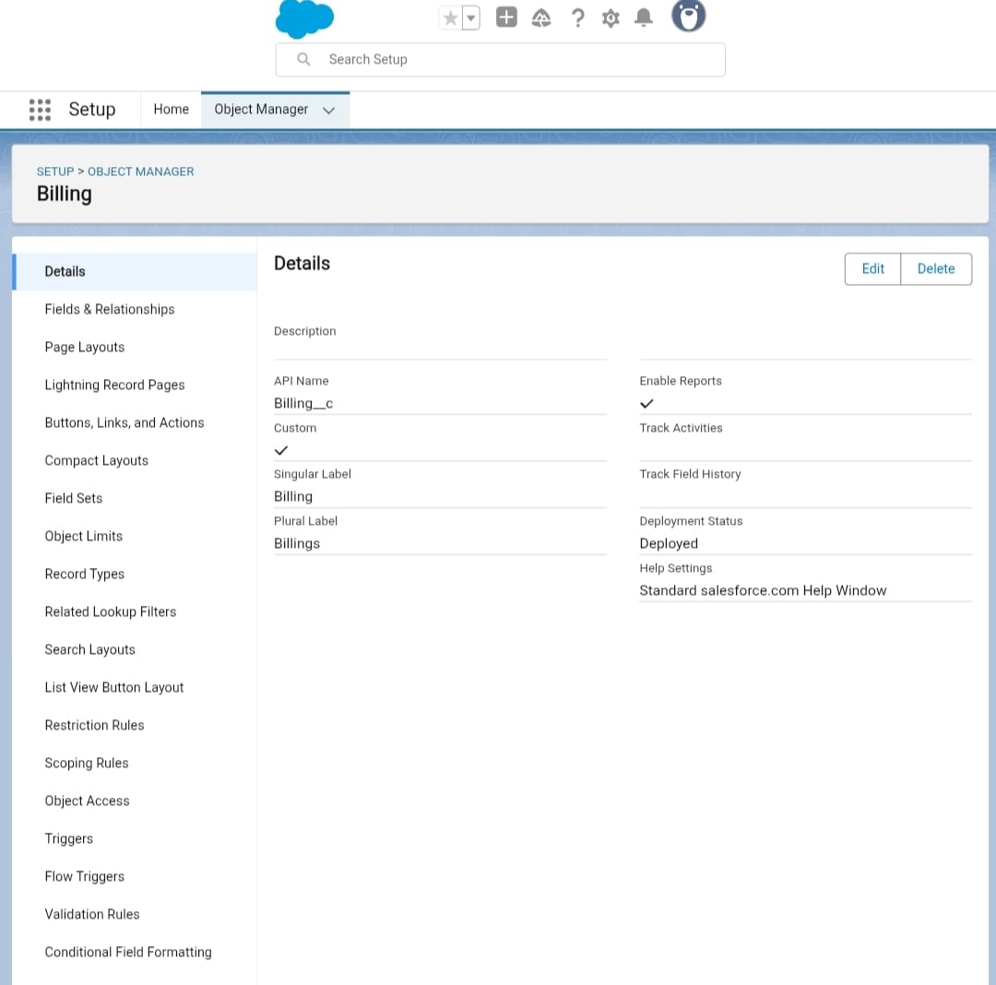

**Creating a Custom Tab for Jewel customer, Item, Customer order, Price, Billing.**

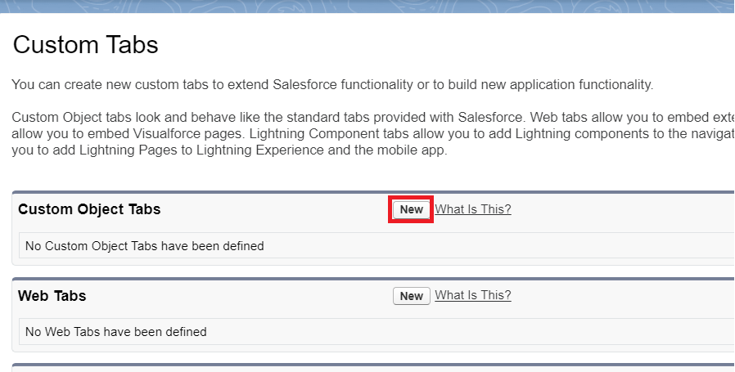

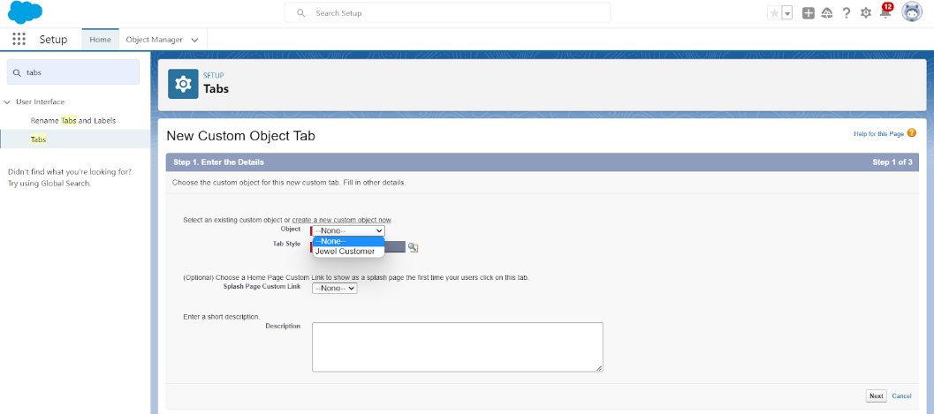

**Create a Lightning App**

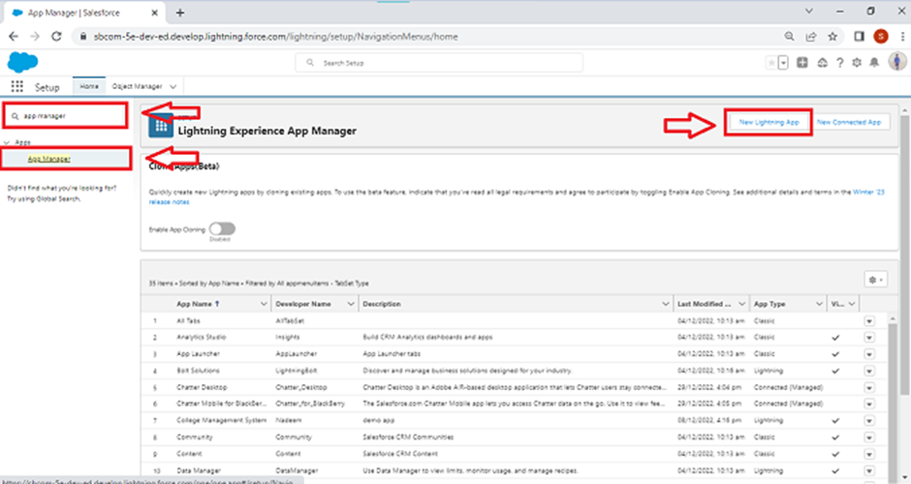

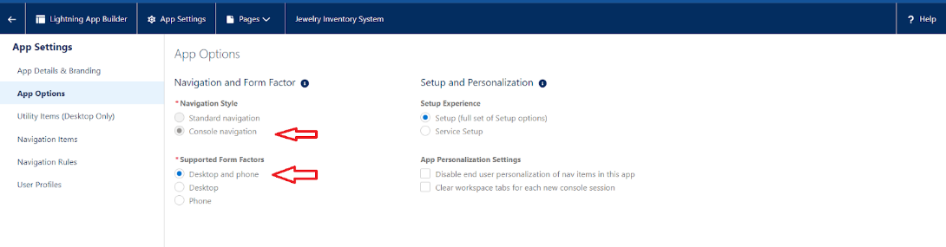

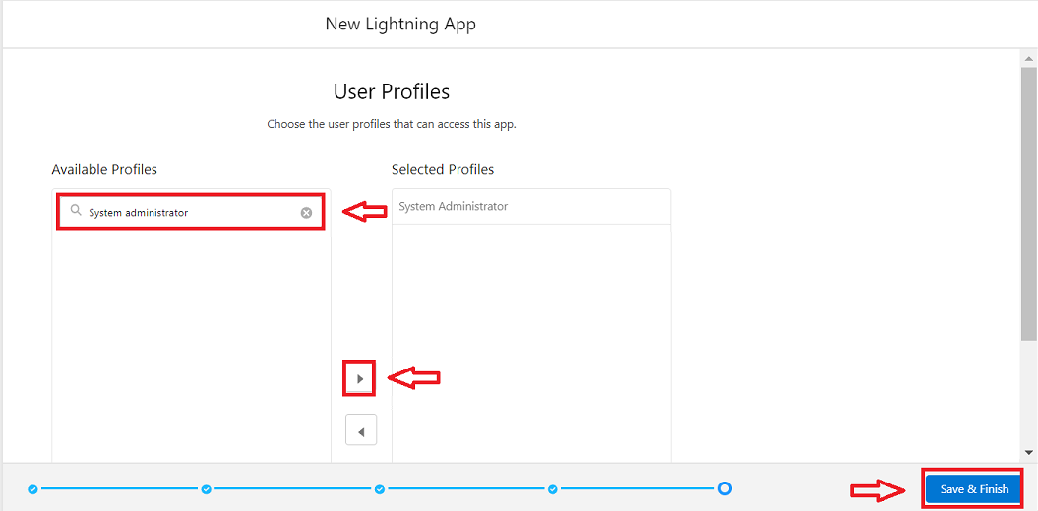

**Fields**

When we talk about Salesforce, Fields represent the data stored in the columns of a relational database. It can hold any valuable information that you require for a specific object. Hence, the overall searching, deletion, and editing of the records become simpler and quicker.

**Creating Lookup Relationship**

A Lookup relationship is a type of relationship in Salesforce that connects two objects together based on a field known as the Lookup field.

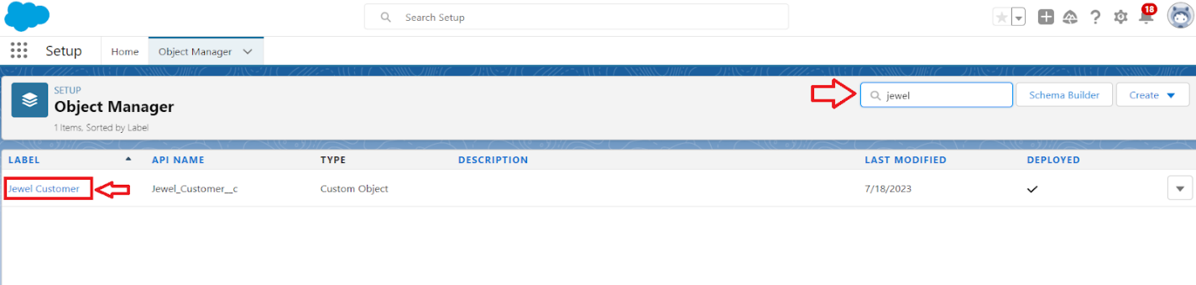

**Creating a Master-Detail Relationship**

Master-detail relationship is a type of relationship between two objects where the master object controls certain behaviours and settings of the detail object

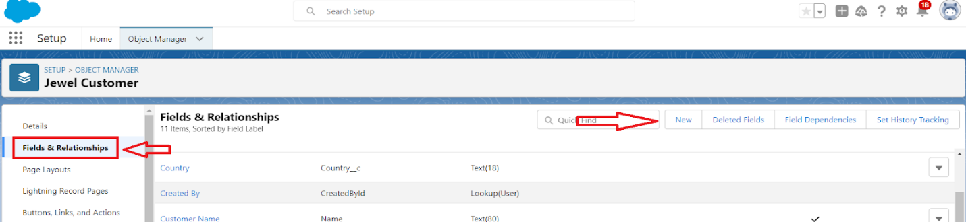

**Creating Text Field in Jewel Customer Object**

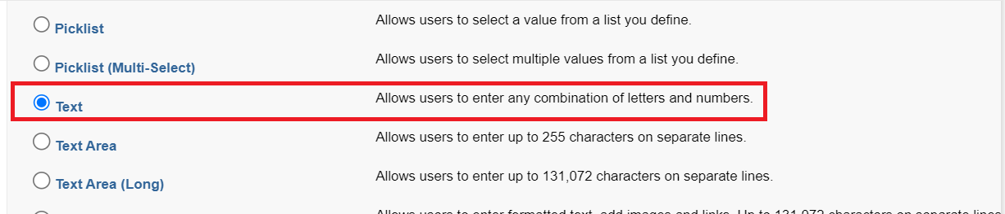

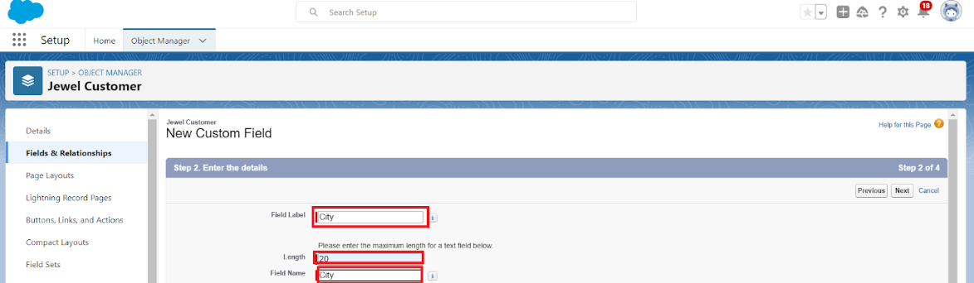

**Creating the Phone field and the email field in object Jewel Customer**

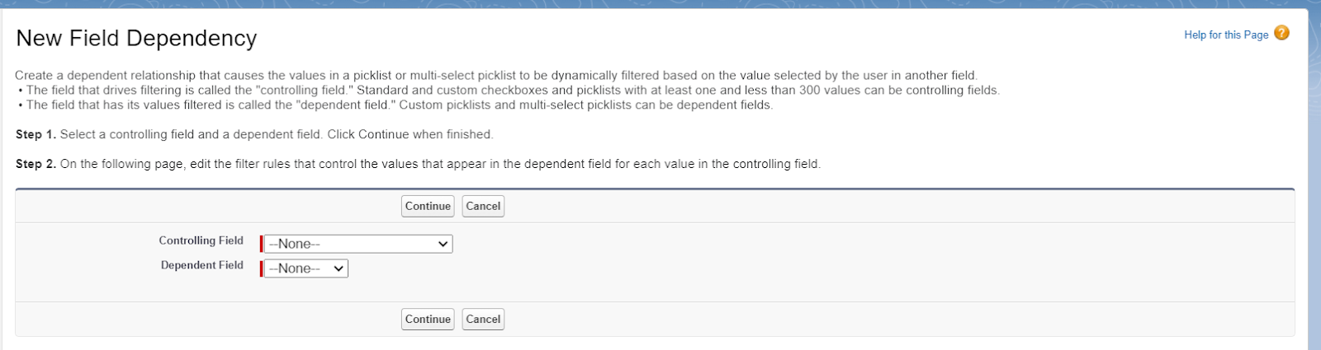

**Creating the number field in Item object ,purity as field label**

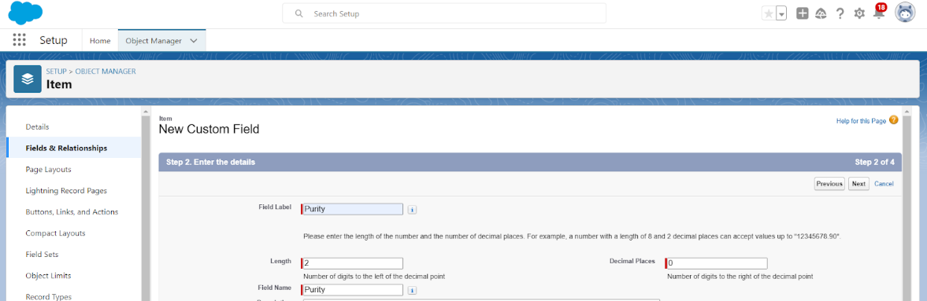

**Creating Picklist Field in Item Object to Enter Values in as Gold and Silver.**

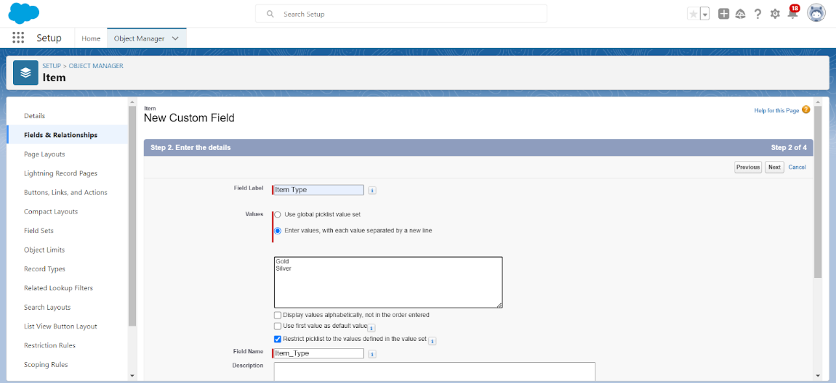

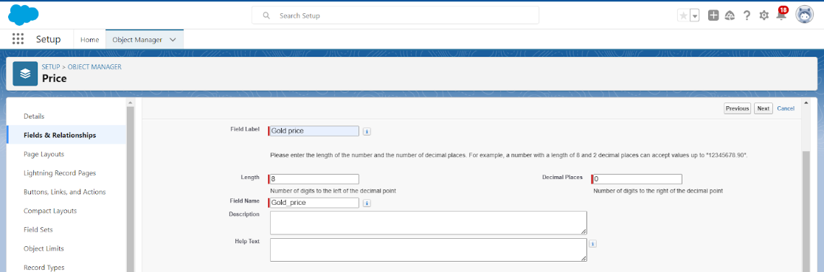**Creating Currency Field in Price Object and set Field Label as Gold price ,length”8” Decimal”0”.**

**Creating Formula Field(Cross Object) in Item Object ,Jewel customer, Customer order, Price,Item,Billing.**

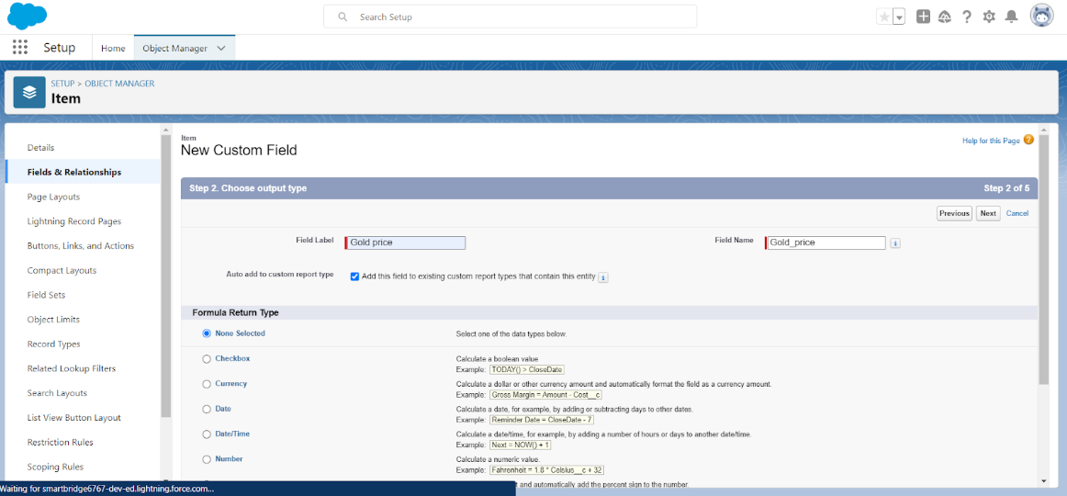

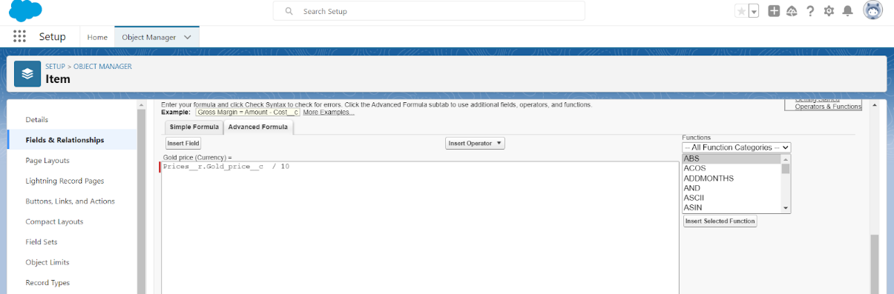

**Creating the Field Dependencies**

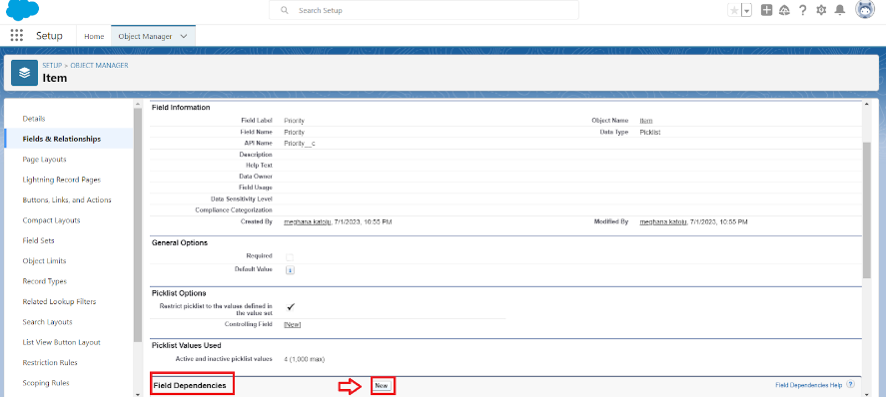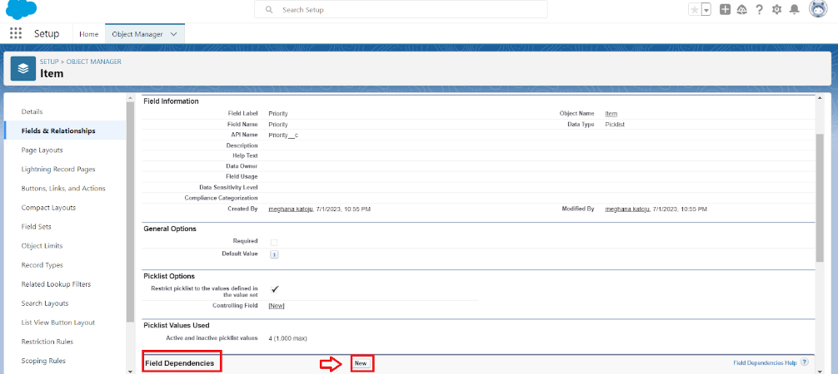

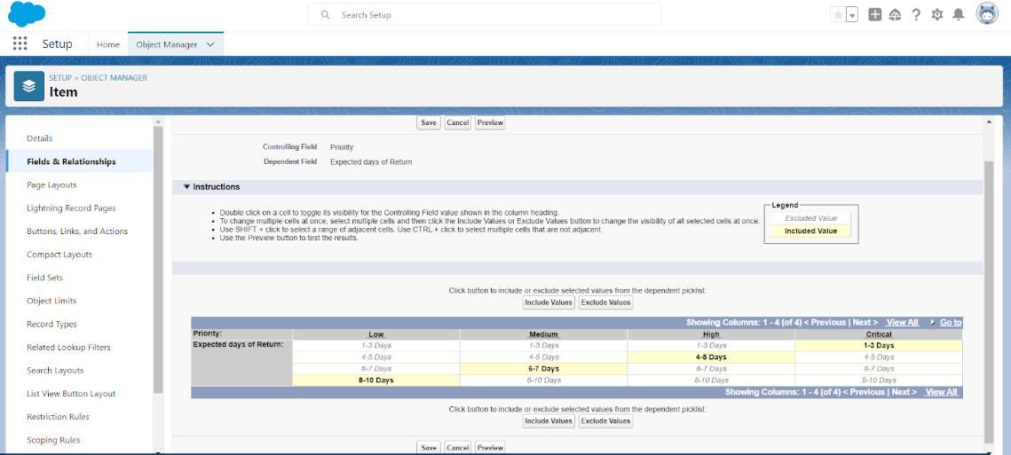

**Creating the validation rule for Jewel customer object and Item.**

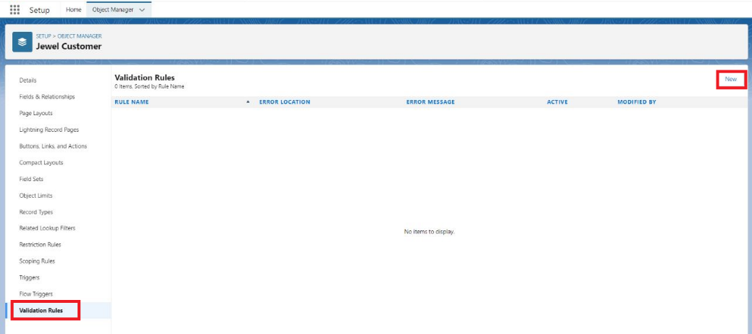

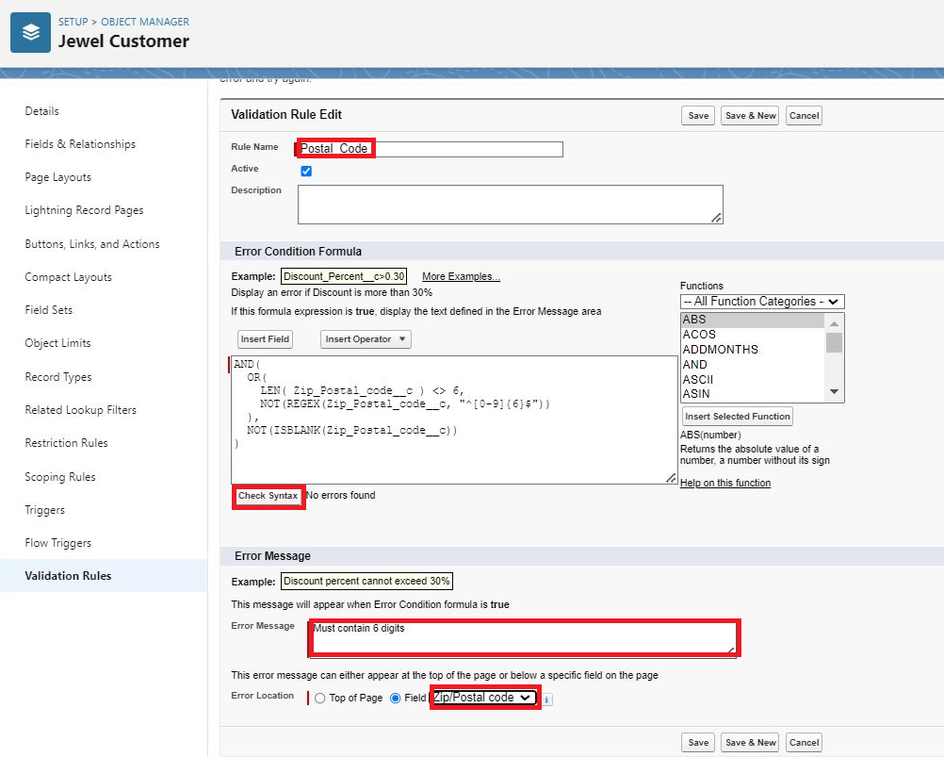

**Profiles:** A profile is a group/collection of settings and permissions that define what a user can do in Salesforce.

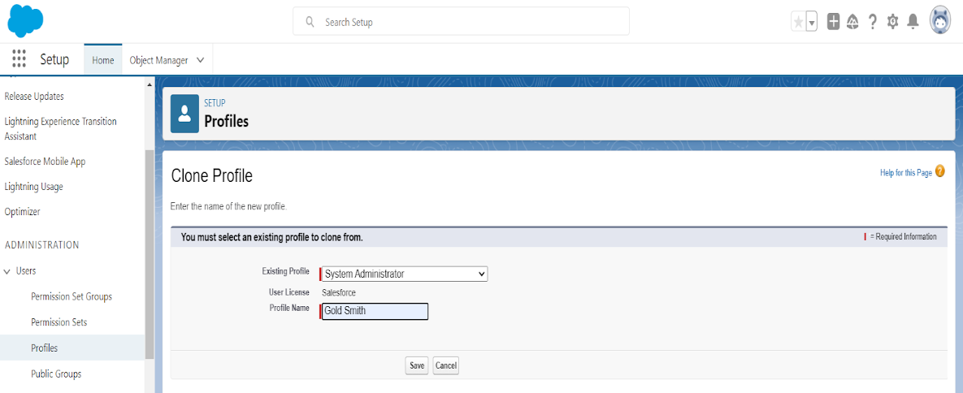**Gold Smith Profile**

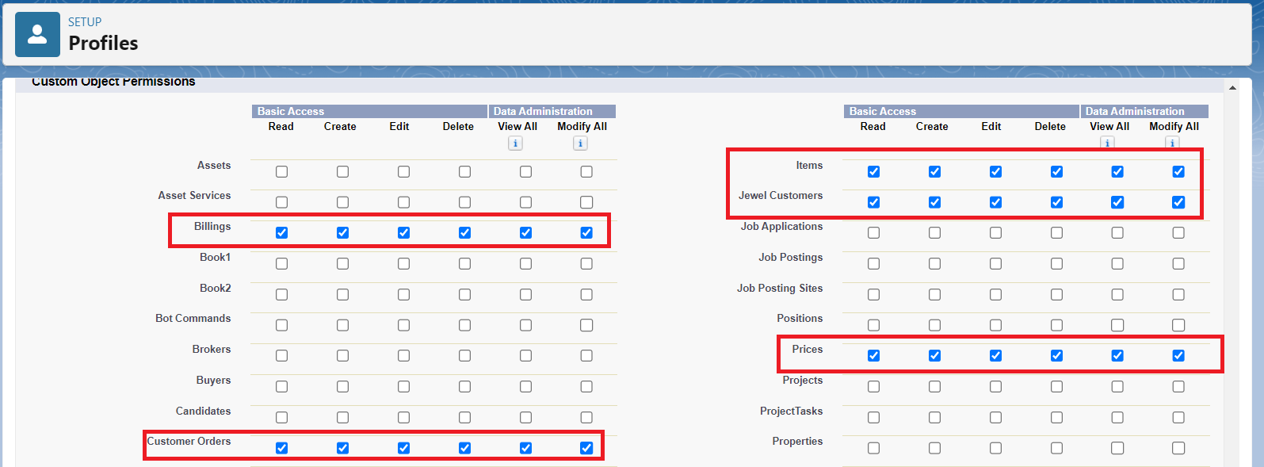

**Roles :**

A role in Salesforce defines a user's visibility access at the record level. Roles may be used to specify the types of access that people in your Salesforce organisation can have to data.

**Creating Gold Smith Role**

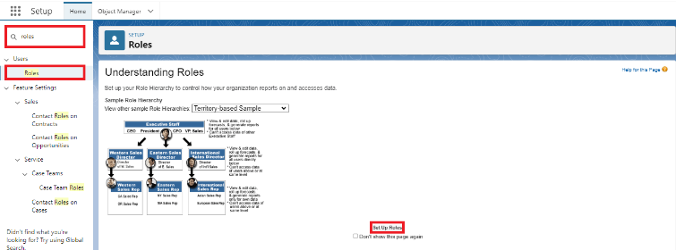

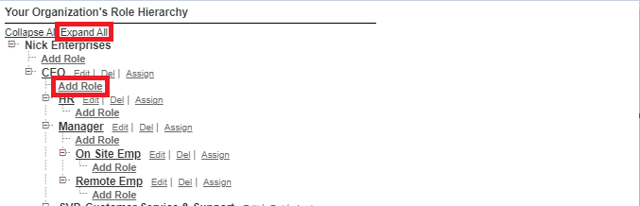

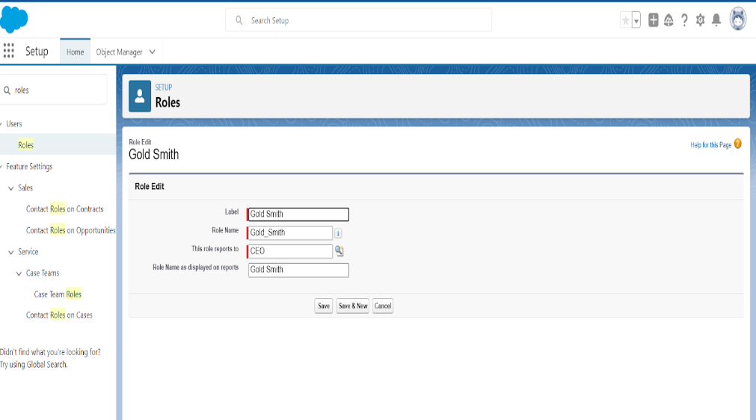

**Users**

A user is anyone who logs in to Salesforce. Users are employees at your company, such as

sales reps, managers, and IT specialists, who need access to the company's records.

**Create User for 3 more fields**

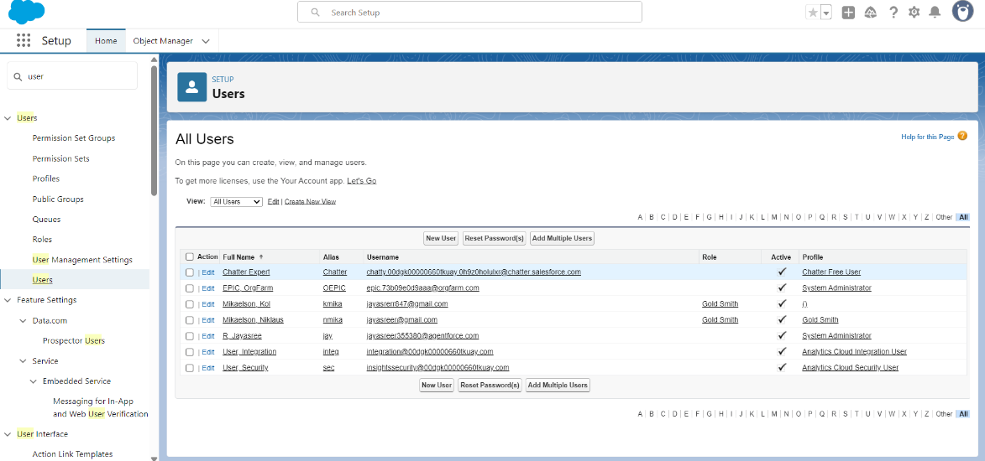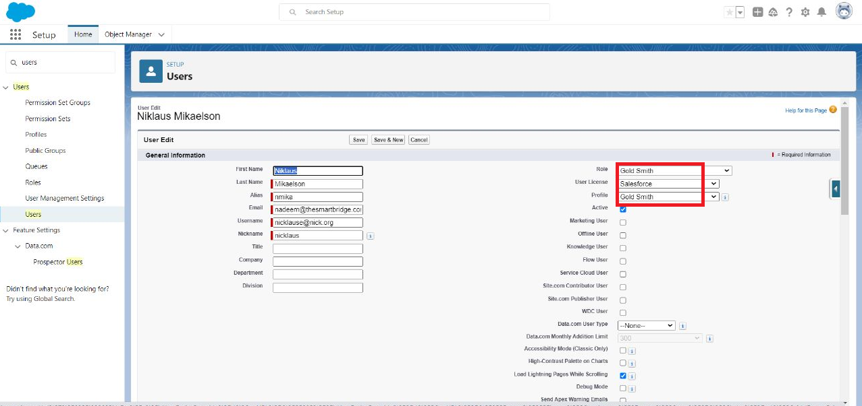

**Page layouts**

Page Layout in Salesforce allows us to customise the design and organise detail and edit

pages of records in Salesforce.

**To Create a Gold Page layout and Silver page layout**

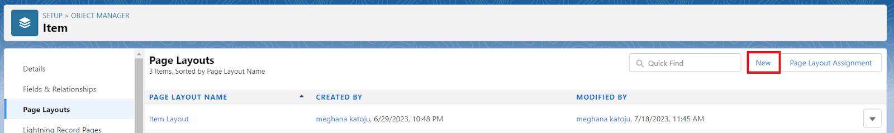

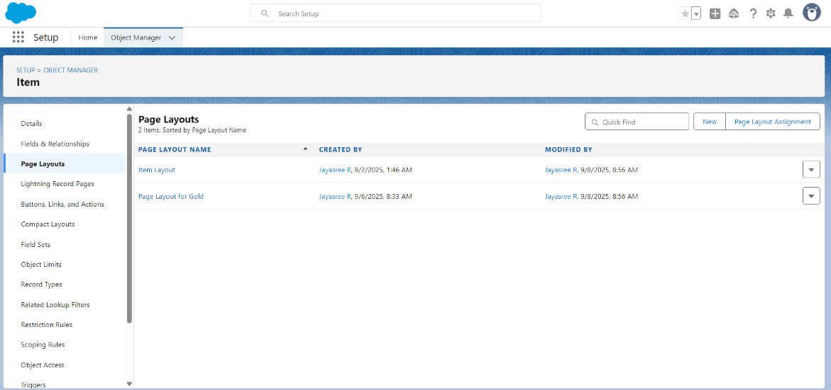

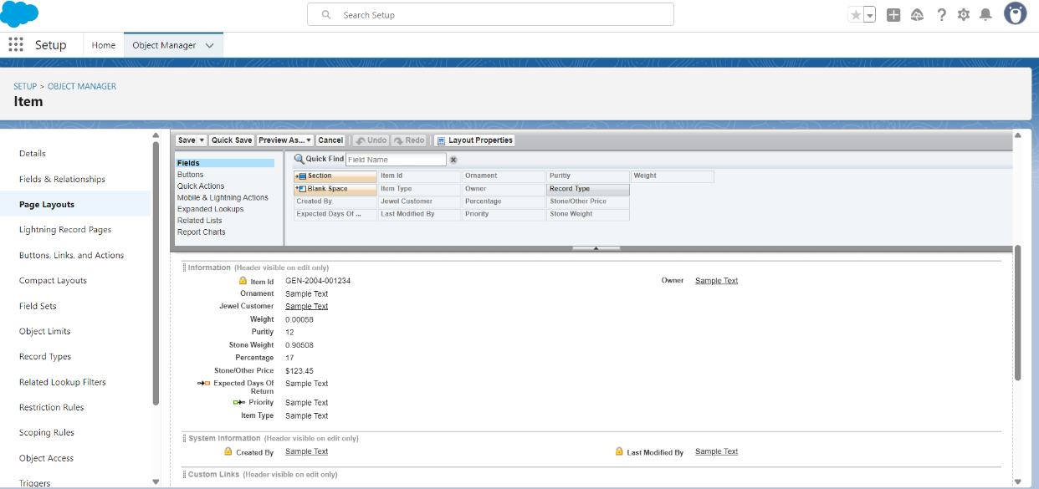

**Record Types**

Record Types are a way of grouping many records of one type for that object. These can be applied to any standard or custom object, and allow you to have a different page layout, fields, required fields, and picklist values.

**To create a Record Type**

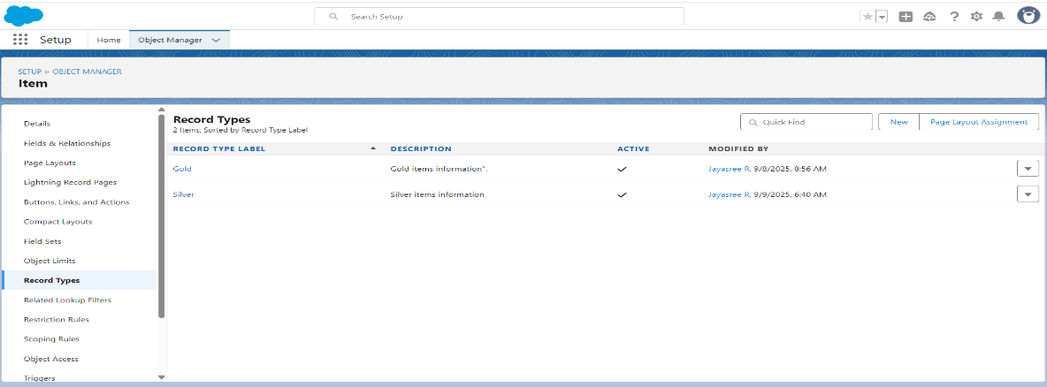

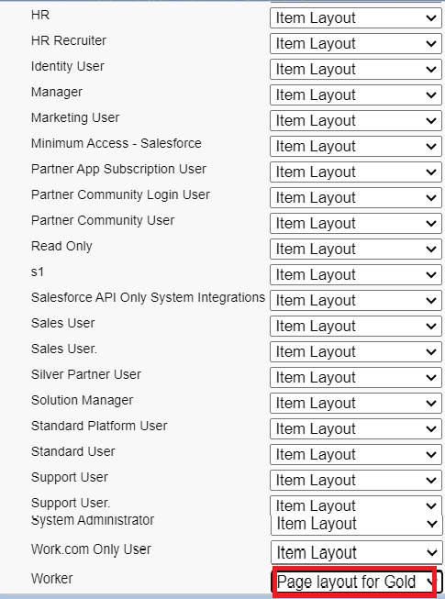

**Permission sets**

A standard permission set consists of a group of common permissions for a particular feature associated with a permission set licence.

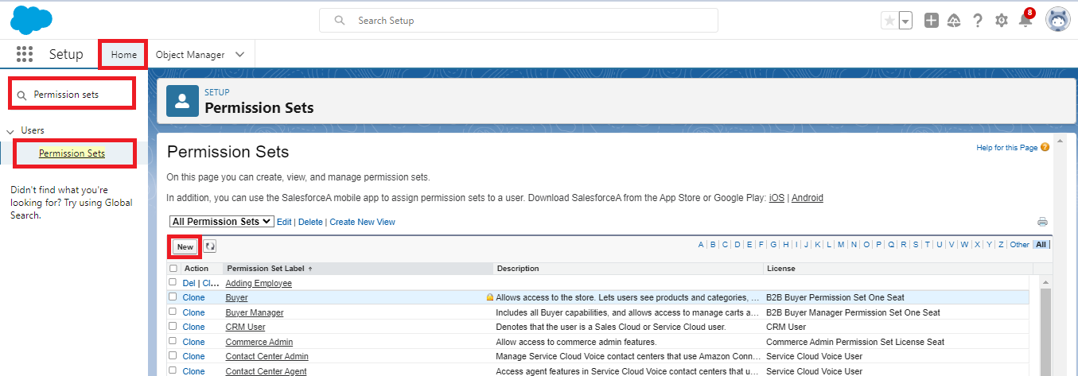**Creating permission set**

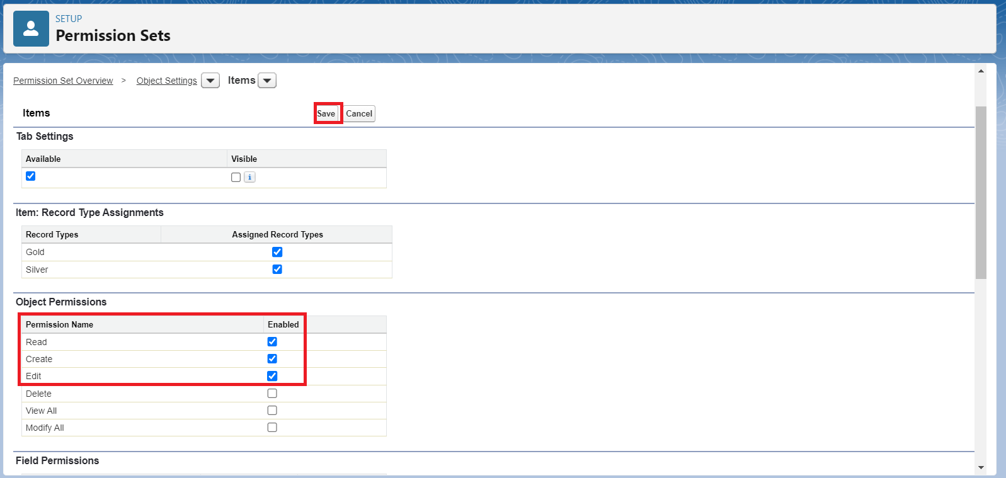

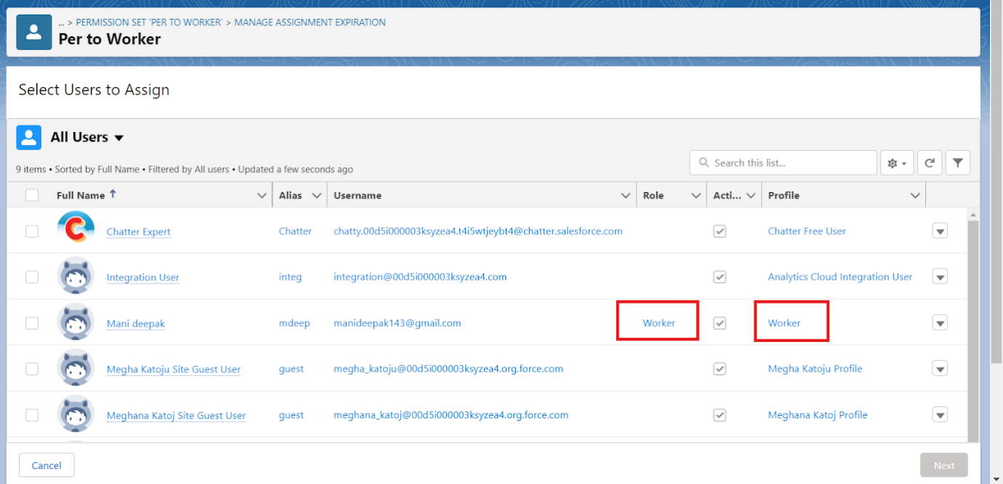

**Trigger**

**Create a Trigger Handler class**

**Trigger handler:**

A trigger handler is a design pattern that organises trigger logic into separate classes. This helps in keeping code organised, reusable, and easier to maintain.

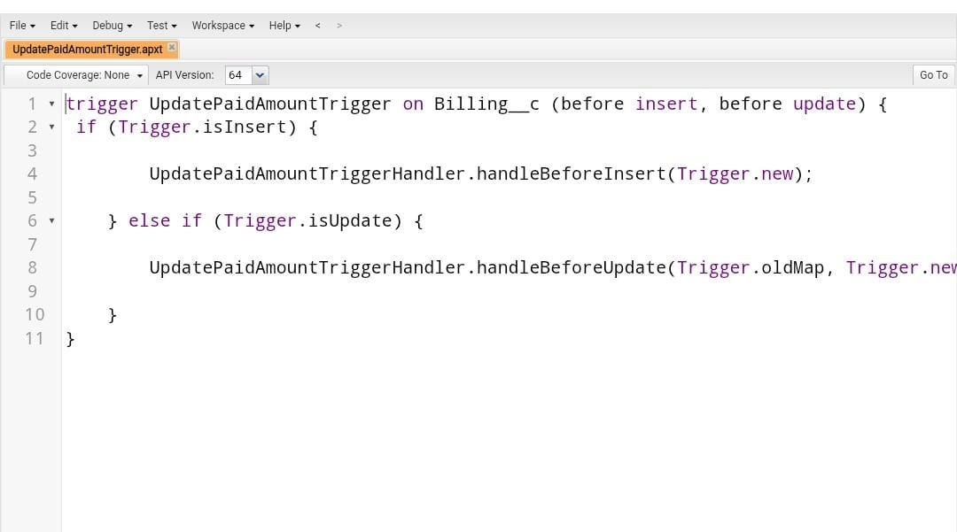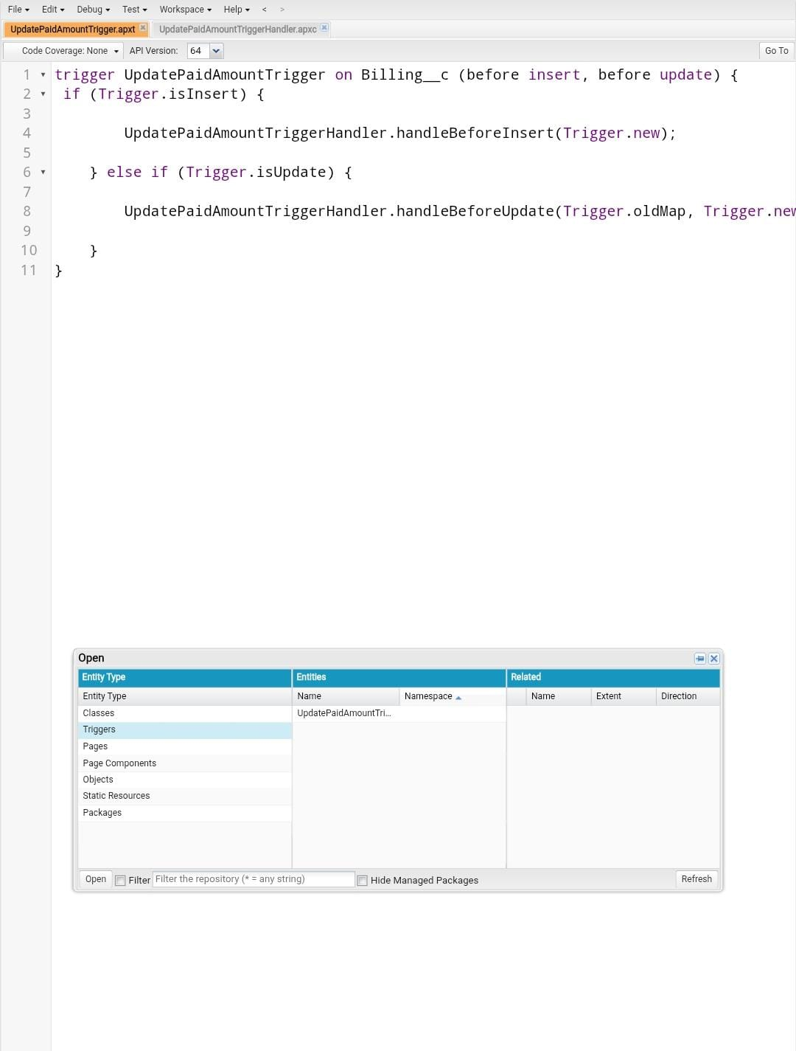

**Create the trigger**

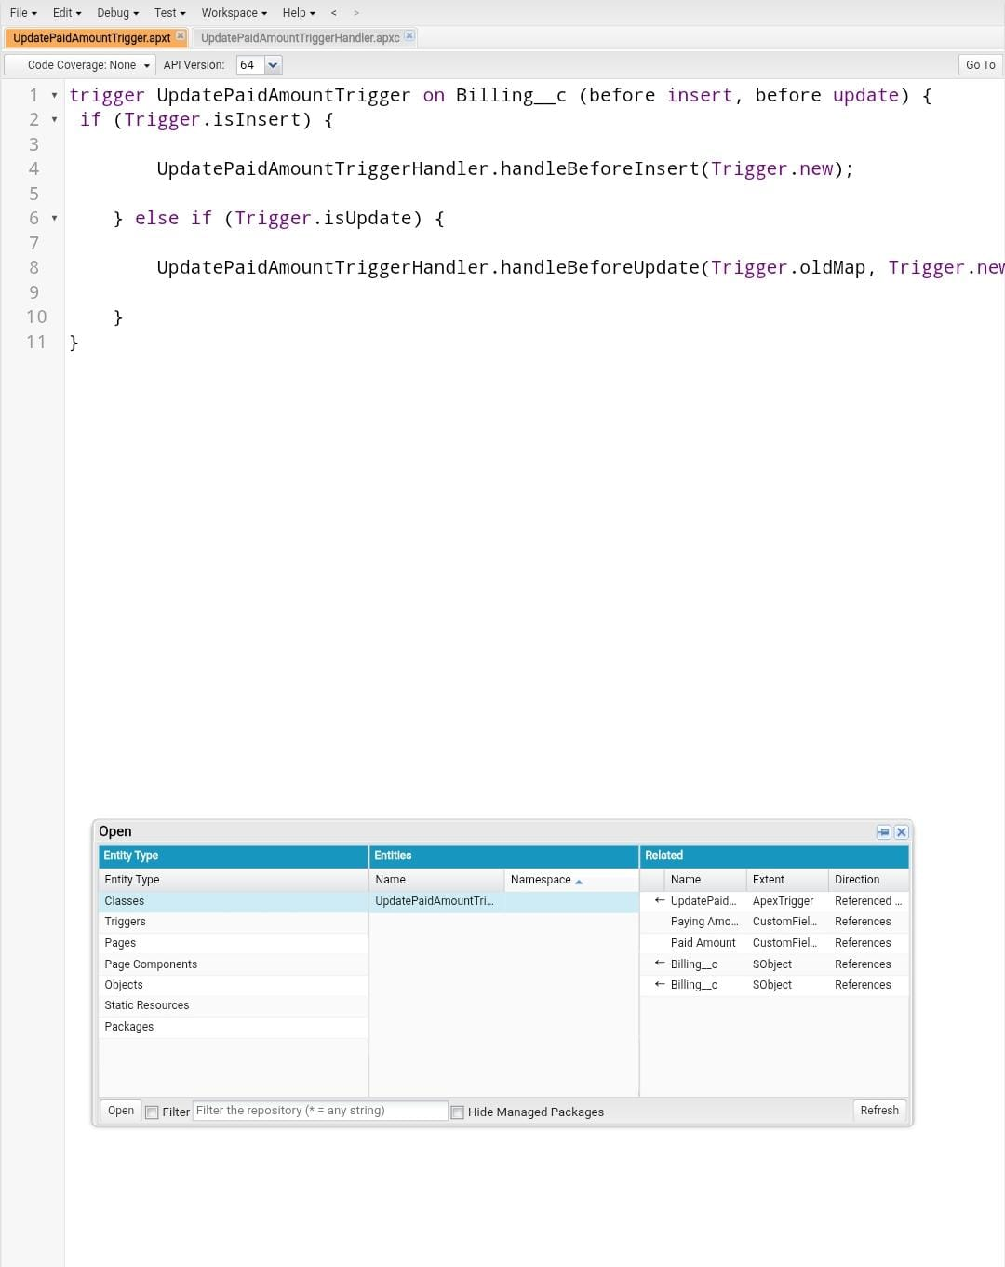

**User Adoption**

**Use Case:**

As a new Administrator, you perform user management tasks like creating and editing users, resetting passwords, granting permissions, configuring data access, and much more. In this unit, you will learn about users and how you add users to your Salesforce org.

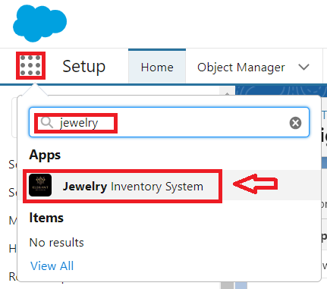

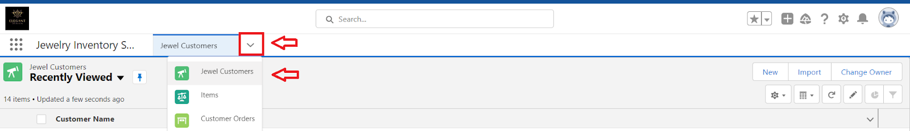

**Reports**

Reports give you access to your Salesforce data. You can examine your Salesforce data in almost infinite combinations, display it in easy-to-understand formats, and share the resulting insights with others. Before building, reading, and sharing reports, review these reporting basics.

**Create Report:** **Item with Billings and Billings with item and Customer order**

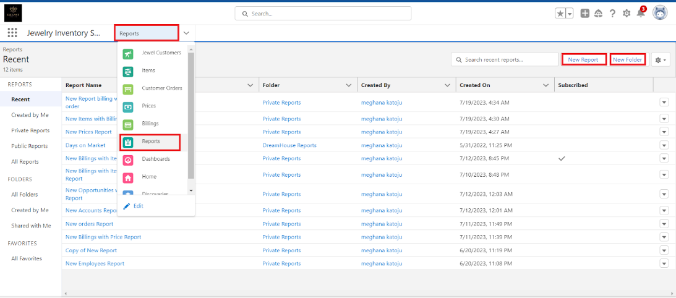

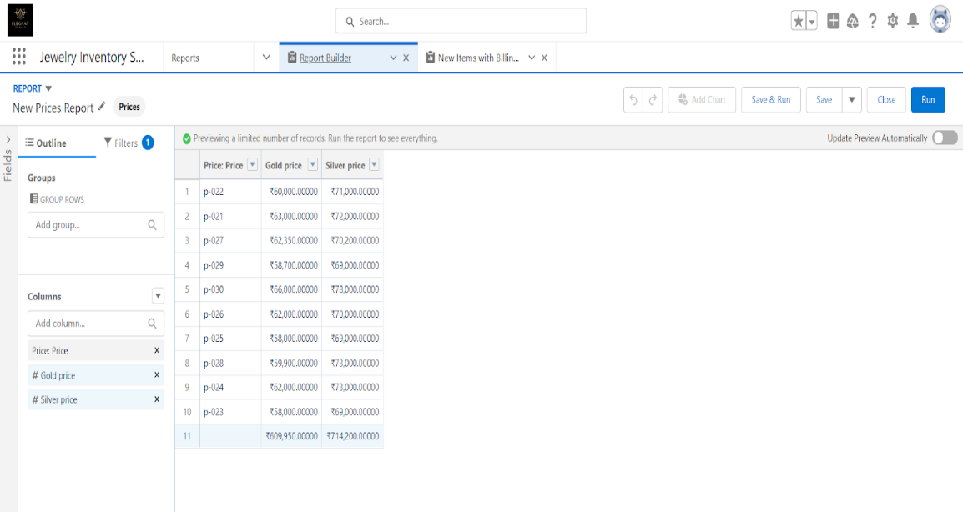

**Dashboards**

Dashboards help you visually understand changing business conditions so you can make decisions based on the real-time data you’ve gathered with reports. Use dashboards to help users identify trends, sort out quantities, and measure the impact of their activities.

**Create Dashboard**

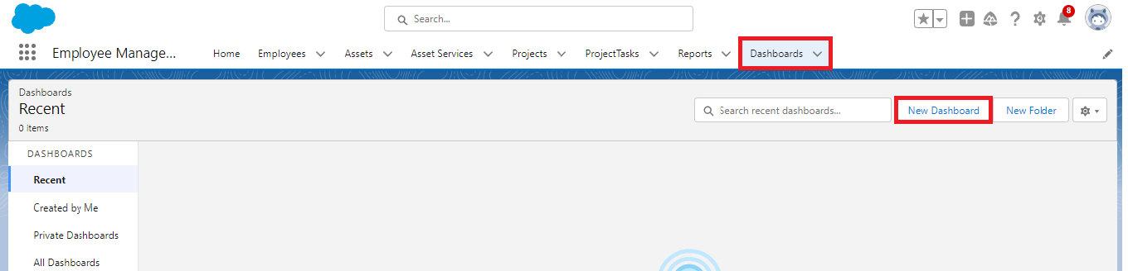

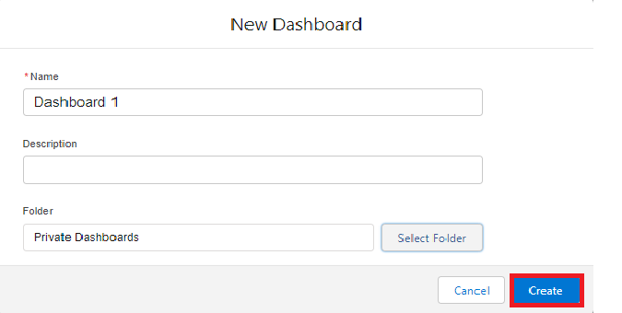

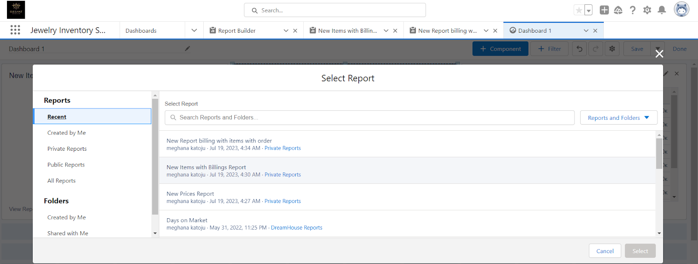

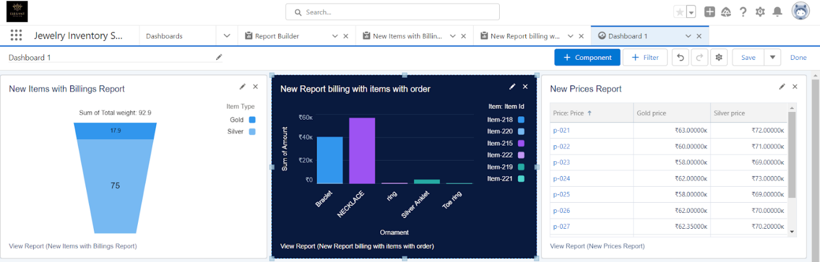

**Flows**

In Salesforce, a flow is a powerful tool that allows you to automate business processes, collect and update data, and guide users through a series of screens or steps. Flows are built using a visual interface and can be created without any coding knowledge.

**Create a Flow**

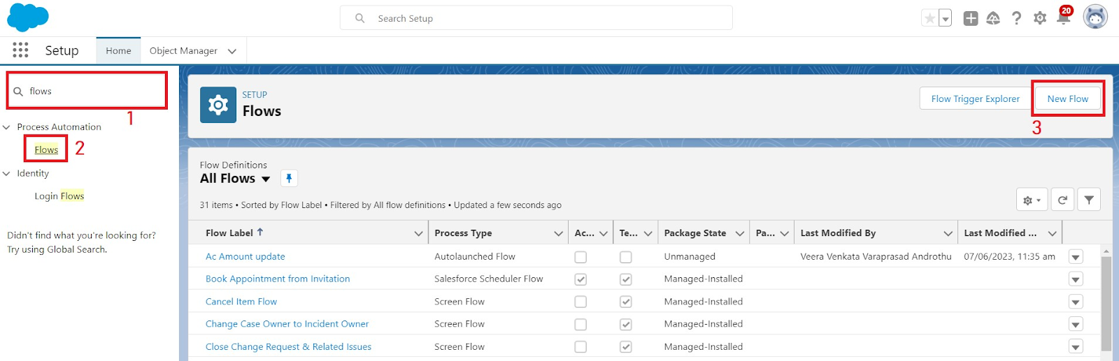

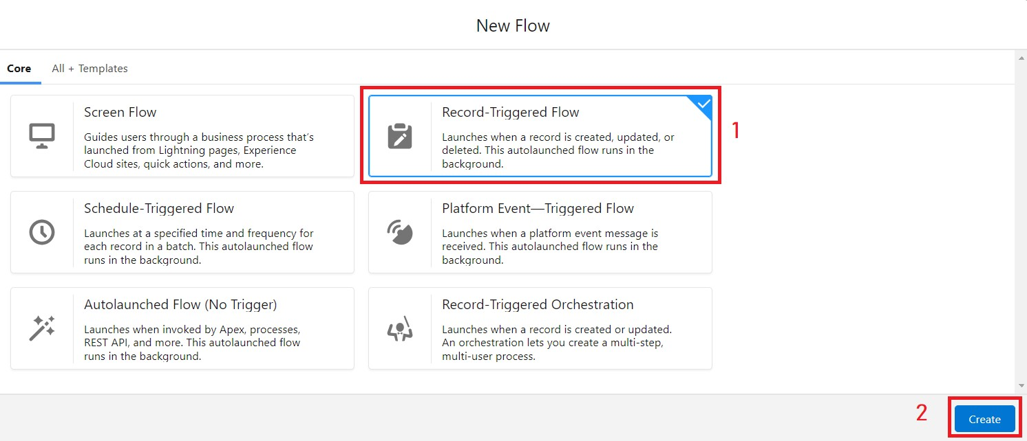

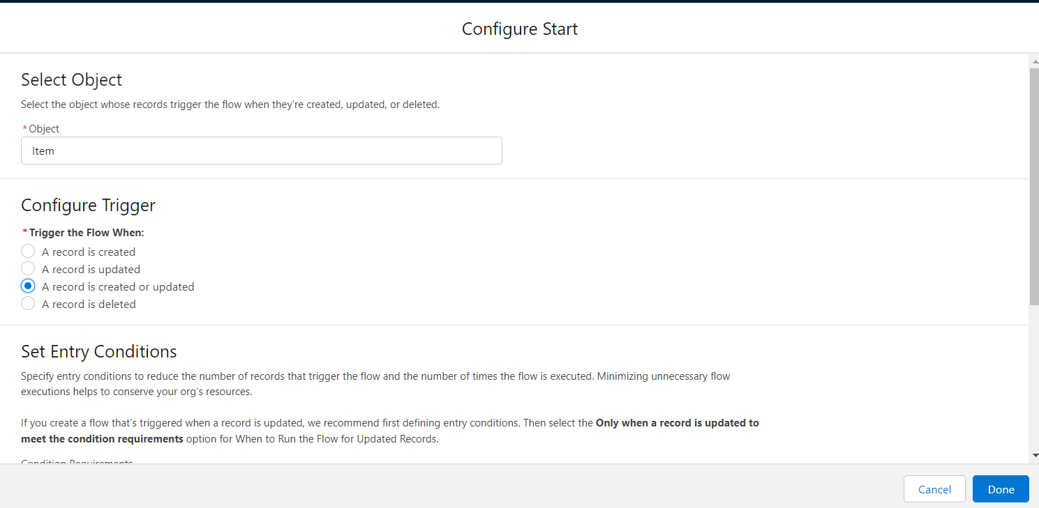

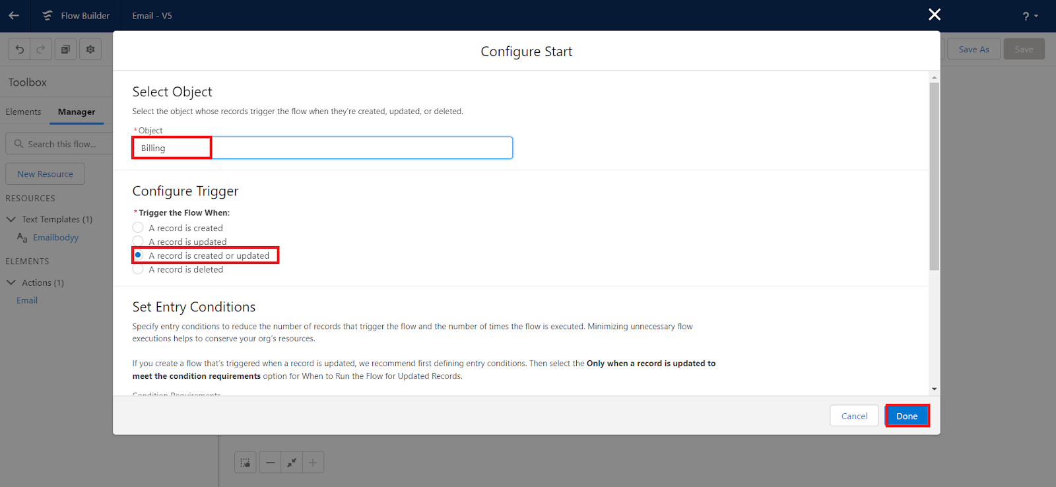

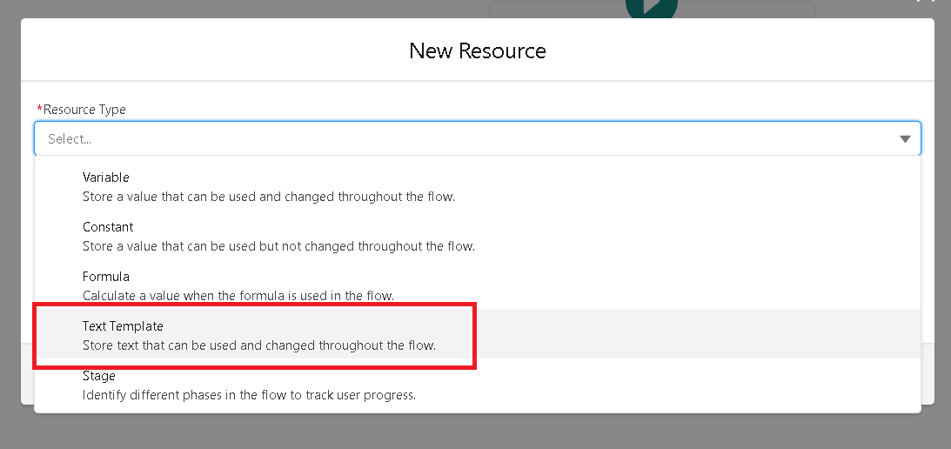

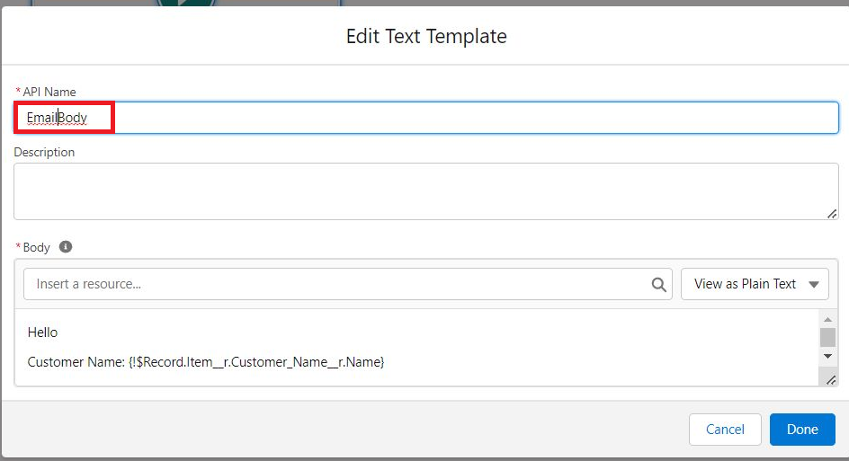

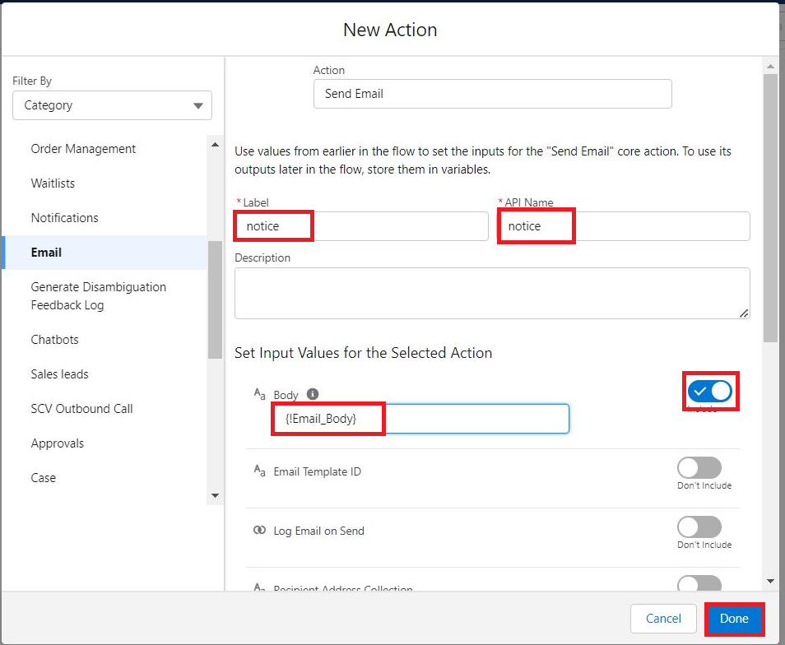

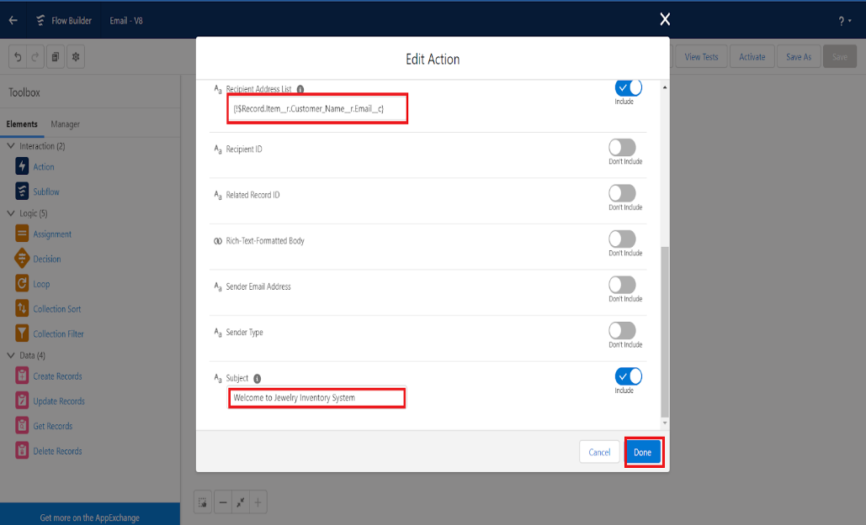

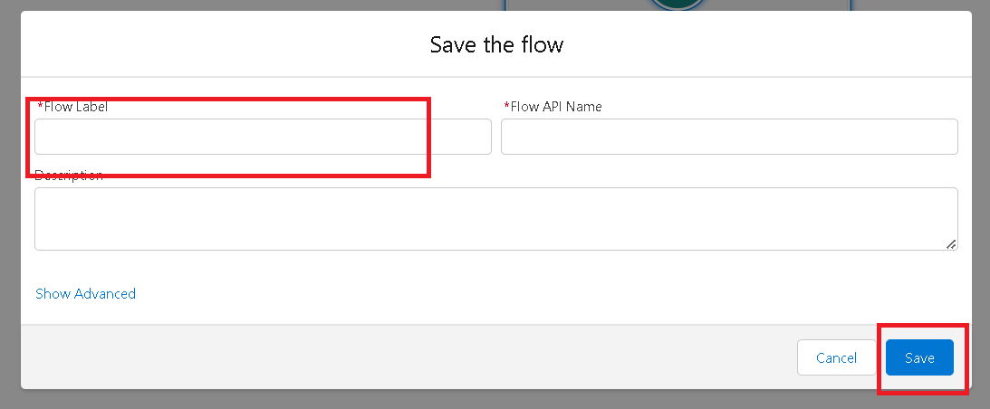

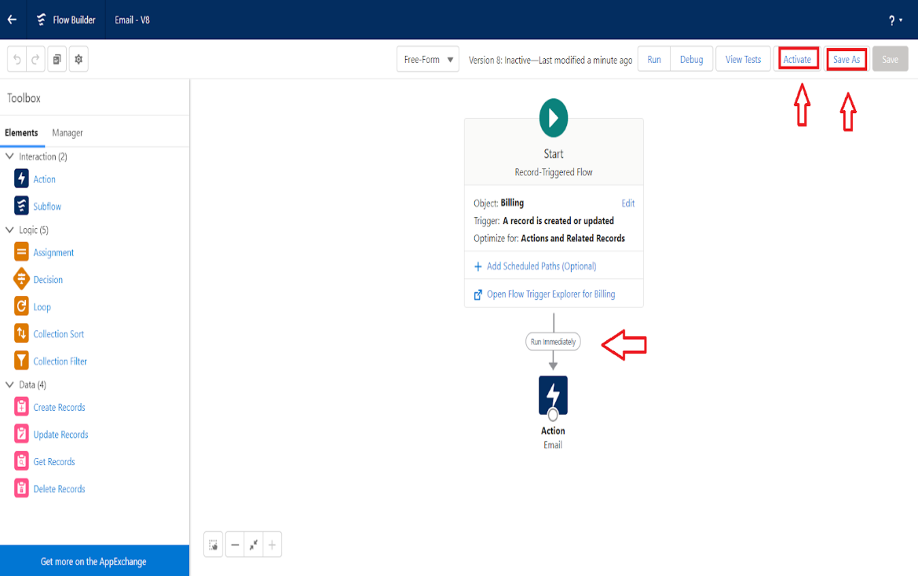

**Testing Approach**

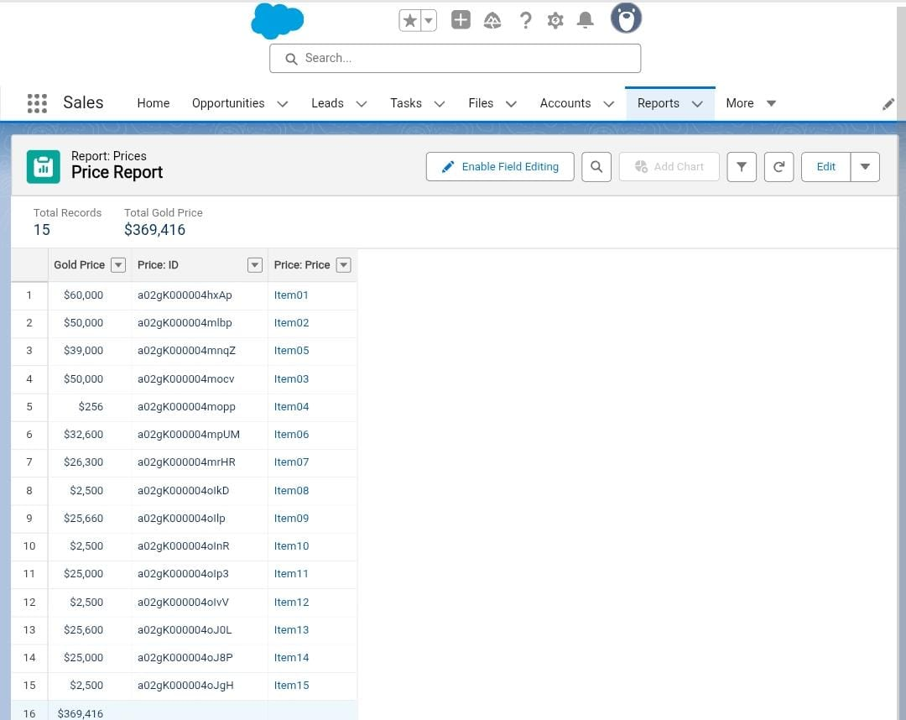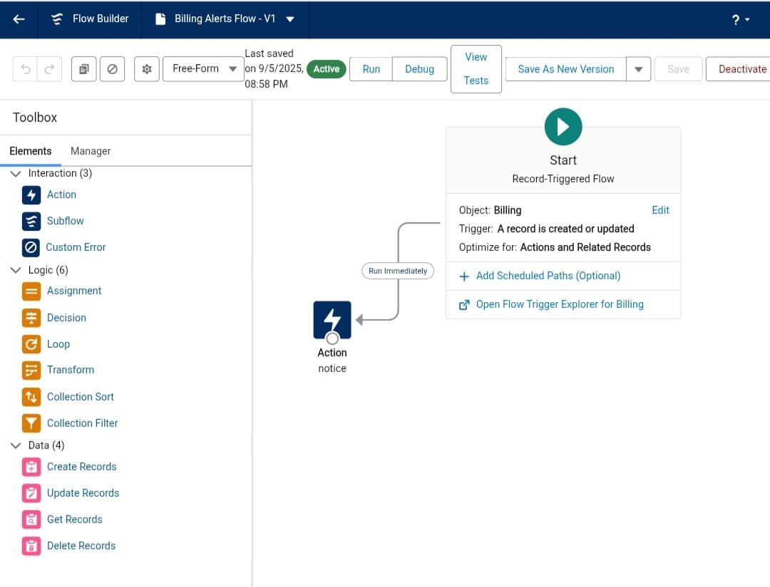

**RESULTS**

**Output Screenshots**

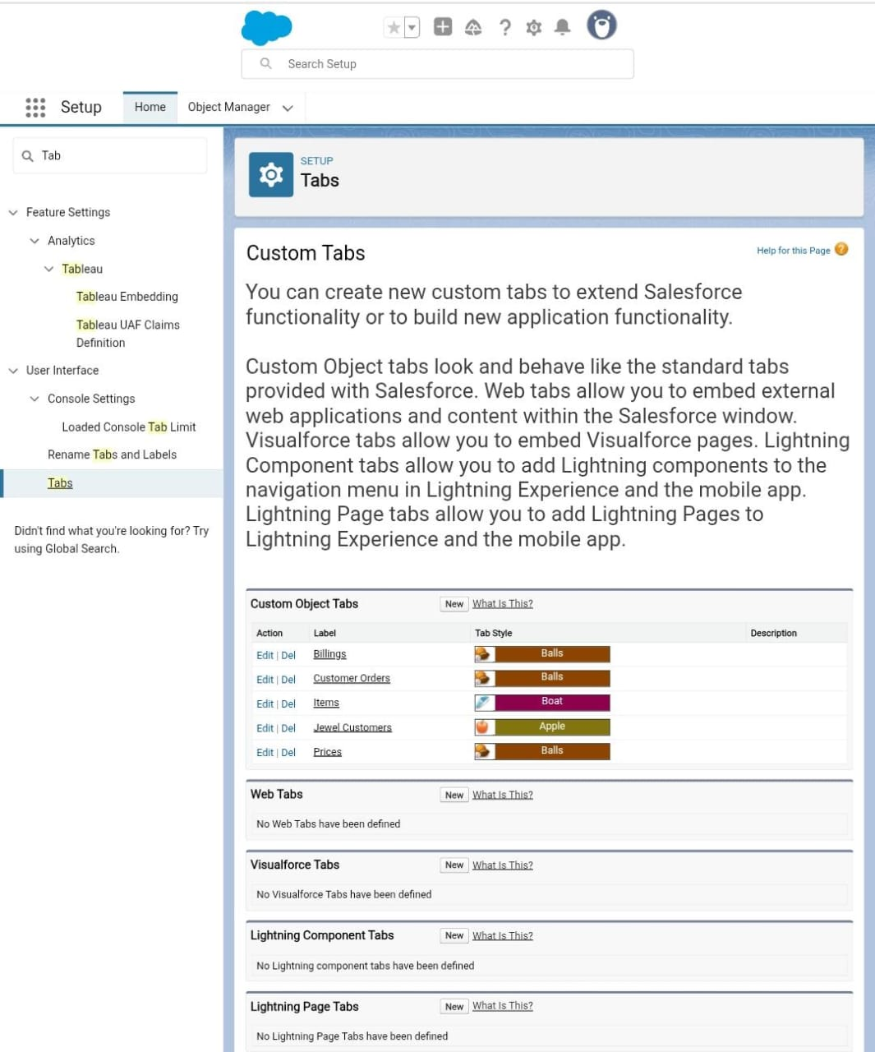

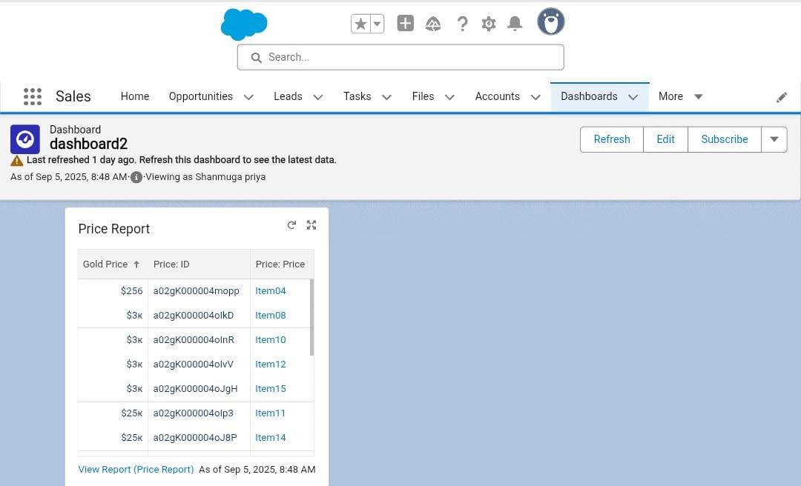

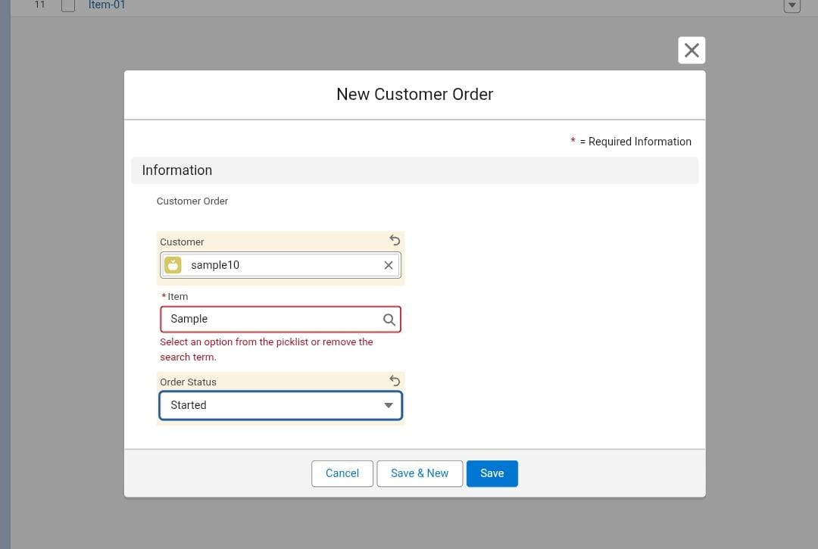**Error Messages**

**APPENDIX**

**Source code**

public class UpdatePaidAmountTriggerHandler {

    public static void handleBeforeInsert(List<Billing__c> newBillings) {

        for (Billing__c billing : newBillings) {

            billing.Paid_Amount__c = billing.Paying_Amount__c;

        }

    }

    public static void handleBeforeUpdate(Map<Id, Billing__c> oldBillingsMap, List<Billing__c> updatedBillings) {

        for (Billing__c billing : updatedBillings) {

            Billing__c oldBilling = oldBillingsMap.get(billing.Id);

            Decimal oldPaidAmount = oldBilling.Paid_Amount__c;

            billing.Paid_Amount__c = oldPaidAmount + billing.Paying_Amount__c;

        }

    }

}

trigger UpdatePaidAmountTrigger on Billing__c (before insert, before update) {

    if (Trigger.isInsert) {

        UpdatePaidAmountTriggerHandler.handleBeforeInsert(Trigger.new);

    } else if (Trigger.isUpdate) {

        UpdatePaidAmountTriggerHandler.handleBeforeUpdate(Trigger.oldMap, Trigger.new);

    }

}

**CONCLUSION**

The development and implementation of a custom CRM Application for Jewellery Management on the Salesforce platform have proven to be a significant success.It Streamlines Key business processes and provide Robust,scalable Solution